SHORT ANSWER STUDY GUIDE QUESTIONS – Number the Stars
Chapters 1 and 2

Directions: As you are reading the story, answer the following questions:
1. Provide a description of character traits for Annemarie Johansen.
2. Provide a description of character traits for Ellen Rosen?
3. Why do the Nazi soldiers stop the girls on Osterbrogade?

4. Who is Kirsti; provide a description of character traits for her.

5. Give the setting (time and place) for this novel. | 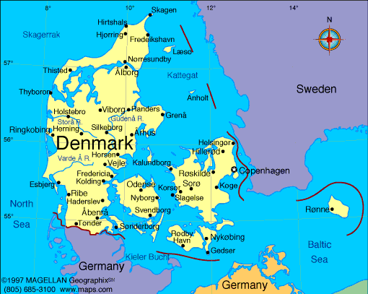
6. What were the girls' mothers drinking instead of coffee? Why?

SHORT ANSWER STUDY GUIDE QUESTIONS – Number the Stars
Chapters 1 and 2 continued…

7. Explain what is meant by Nazi occupation.
8. Who or What is the Resistance?

9. How did Resistance members operate? Give an example of what they did.

10. What does Kirsti beg to be told?
11. What significance is there to being greeted by a king?
12. Name King Christian X's bodyguard.

13. Why did King Christian X surrender to the Nazis rather than fight them?

14. What nearby country to Denmark remained neutral?
15. Why didn't Annmarie and Kirsti’s sister, Lise, marry her fiancé Peter?
16. According to Annemarie, the whole world had changed, except one thing. What?

SHORT ANSWER STUDY GUIDE QUESTIONS – Number the Stars
Chapters 3, 4

Directions: As you are reading the story, answer the following questions:
1. Why did the Rosens install a stove in their chimney? | 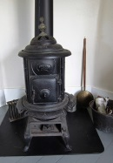
2. Mr. Rosen was frustrated while grading his school papers at night. Why?

3. What discovery did the girls make when they stopped at the button shop on their way home?

4. Who does Annemarie say must be the bodyguard of the Jews?

5. Describe Peter; provide character traits.

6. Why is it frightening to Kirsti for Peter to visit them late at night?

7. For what was Annemarie glad as she snuggled herself back in bed after Peter's visit?

8. What caused Kirsti to be so upset upon her and Mama's return from shopping?

9. How does Ellen offer to solve this problem?

10. Kirsti was told there was a firework display for her birthday. What really happened?

SHORT ANSWER STUDY GUIDE QUESTIONS – Number the Stars
Chapters 3 and 4, continued …

11. What causes the Rosens to change their plans to celebrate the Jewish New Year?

12. What is meant by the term 'relocation'?

13. In what ways do the Johansens help the Rosens that day?

SHORT ANSWER STUDY GUIDE QUESTIONS – Number the Stars
Chapters 5, 6

Directions: While you are reading, answer these questions.
1. What does Ellen want to be when she grows up?

2. How does Ellen verbally express the sadness she felt when Annemarie's sister Lise died?

3. Where are Lise's things packed away? Why? What room is it located in? | 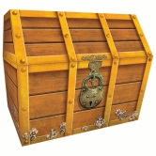
4. Why do the Nazi soldiers come to the Johansens' apartment in the middle of the night?

5. Why does Annemarie yank Ellen's necklace from her neck?

6. What is different about the soldiers who come to the apartment and the soldiers who had stopped the girls on the street?

7. In what way does the soldier insult Mama?

8. Why does Papa tear the photographs from the family album to show the soldiers?

9. How does the officer treat the baby photograph of Lise?

10. After the soldiers leave, Annemarie realizes she has an imprint of what in her clenched hand?
SHORT ANSWER STUDY GUIDE QUESTIONS – Number the Stars
Chapters 5, 6 continued…

11. Mama and Papa speak of Lise the night the Nazis come to their apartment. How long had it been since they had done so?

12. Why does Mrs. Johansen think her husband should stay home from the trip to her brother's?

13. When her father calls Uncle Henrik, he uses two phrases that confuse Annemarie. What are they?

14. Annemarie is nervous and afraid when the soldiers on the train listen to the chatter of her younger sister, Kirsti. What is she afraid Kirsti will say?

15. Once they arrive in Gilleleje and debark from the train, instead of taking the road, how do Mama and the girls reach Uncle Henrik's house? How far is it?

SHORT ANSWER STUDY GUIDE QUESTIONS – Number the Stars
Chapters 7 and 8
Directions: As you are reading the story, answer the following questions:
1. Describe Uncle Henrik's house.
Use good, solid details from the book.
You can draw a picture, if you would like.

2. While looking at the sea, what information does Ellen share with Annemarie about her mother?

3. What country do Annemarie and Ellen see from the seashore?

4. In what way does Mama warn the girls when they return from looking at the sea?

5. Compare the girls' usual breakfast in Copenhagen to their breakfast at Uncle Henrik's.

6. What rationed item do Annemarie and Mama joke about? Tell the joke, and why it is funny.

7. How does Mama spend her second day at Uncle Henrik's?

8. Annemarie hears Mama and her uncle use two familiar, yet unknown phrases again. What are the two phrases?

9. There is to be a funeral at Uncle Henrik's house. Who is it for and why does this confuse Annemarie?

SHORT ANSWER STUDY GUIDE QUESTIONS – Number the Stars
Chapters 9 to 11
Directions: As you are reading the story, answer the following questions:
1. Uncle Henrik admits that he and Mama lied to Annemarie. What reason does he give her?
2. After Uncle Henrik tells Annemarie some of the truth, why doesn't she tell Ellen?
3. Other than Peter, what familiar couple is among the people that arrive for the funeral at Uncle Henrik's?

4. What does Mama tell the Nazi soldier when he asks why the casket is not open?
5. When Mama offers to open the casket, what does the Nazi soldier do?

6. What is Annemarie thinking while Peter reads the psalm aloud?

7. What is hidden in the casket?

8. What does Peter do to the baby in the group? What does the mother say? What ultimately happens?

9. Peter gives something to Mr. Rosen. What are Peter's instructions to Mr. Rosen?

10. What does Peter do that shows Annemarie that he is now an adult, like her mother or father?

11. Stripped of all their possessions and deeds, what quality does Annemarie still recognize in the Jews as they depart for the boat?

SHORT ANSWER STUDY GUIDE QUESTIONS – Number the Stars
Chapters 12 to 15
Directions: As you are reading the story, answer the following questions:
1. On what does Mr. Rosen trip outside Henrik's house?

2. How long does Annemarie decide it will take for her mother to return from taking the Rosens down the path to the harbor?
3. What happens to delay Annemarie's mother's return from the harbor?

4. While examining her mother's ankle at the foot of the steps, what does Annemarie find?

5. What must Annemarie take to Uncle Henrik and how does Mama hide it?

6. What story does Annemarie tell herself while she is traveling on the path?
7. Who does Annemarie will herself to act like when the soldiers stop her on the path?

8. What do the German soldiers do with Uncle Henrik's lunch?

9. What do the soldiers do with the packet that is in the bottom of the basket?

10. When Annemarie finally reaches the harbor to give her uncle the basket, why is she puzzled?

SHORT ANSWER STUDY GUIDE QUESTIONS – Number the Stars
Chapters Chapter 16 - Afterword

Directions: As you are reading the story, answer the following questions:
1. Upon her return to Uncle Henrik's house, what does Annemarie have to do for the first time?
2. How does Uncle Henrik explain 'brave' to Annemarie?

3. How do the fishermen smuggle the Jews out of Denmark to Sweden?

4. Why are the handkerchiefs important to the fisherman?

5. How does Uncle Henrik say Annemarie helped the Jews?

6. How many more years does the war last?
7. What happens to Peter?

8. What is the truth about Lise's death?

9. After Annemarie retrieves Ellen's broken necklace from the trunk, what does Annemarie ask her father?

10. Is this a true story?

11. What parts of this story are historically accurate?

12. The author fashioned the character Peter from a courageous young man she met during her research. What does this young man wish for his country in his deathbed letter?

