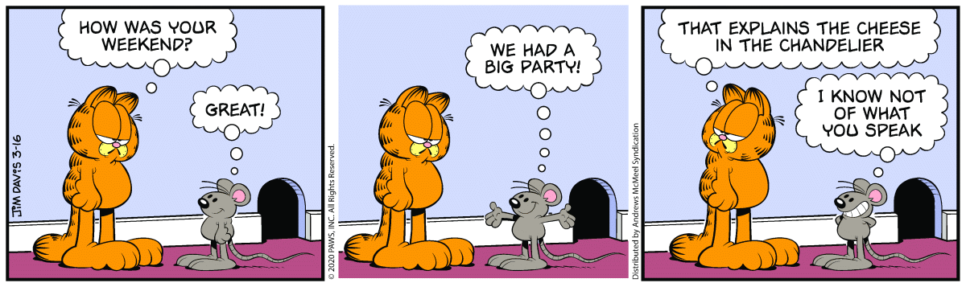
Number the Stars Lesson:
- Sequencing
- Details

Comic Project:

You are assigned one of these sections of the story, based on the month of your birthday (January – 1, February – 2, etc.). You will be drawing the pieces of your event, cartoon-style (see the Garfield picture above). **Make sure to look at the number before and after yours to make sure you are not including details that someone already has.**

4 ways to draw your comic: You can use another piece of paper, you can use Google Classroom, you can draw it in Powerpoint, or you can use the back of this paper for your picture squares. You choose what works best for you!

- Coming Home from School, on the run! (racing, being stopped, finding Mama)

- The Awful Night (the soldiers coming to find the Rosens, Lise’s picture, the necklace imprinted on Annemarie’s hand, etc.)

- Trip to Uncle Henrik's house (train, walk to the house)

- There has been a death (milking Blossom, preparing the living room, picking flowers for the vases, Great Aunt Birte)

- Why Are You Lying? (AnneMarie angry, different people coming to the house, reuniting Rosens)

- Let Us open the Casket (Henrik leaves, soldiers come, pushes Mama, Peter reads from the Bible)

- Will we See you again Peter (gives the clothes and blankets out, baby medicine, Mr. Rosen receives the package; Peter leaves with the first group)

- Where is Mama? (Mama leaves with her group, Annmarie falls asleep, sees Mama in the very early morning)

- Run as fast as you can (Runs out to find Mama, finds the package, makes lunch)

- On the dark path (running, walking fast, turns, path)

- My Dogs Smell Meat (interaction with the soldiers, gets to Henrik at the boat)

- What happens after Annemarie leaves? As told to Annemarie, by Henrik, in the Milking Shed.

